Table of Contents
Introduction 2
Economic Impact 2
Six major players in the construction industry in the world 3
Six major players in the construction industry in the Netherlands 3
Industry Analysis 4
The Biggest challenges in the mentioned companies 6
Three selected companies 7
1. Aalberts N.V. 7
2. Koninklijke BAM Groep nv (Royal BAM Group N.V.) 8
3. Heijmans N.V. 8
References 9

Introduction
The construction industry plays a vital role in the European Union's economy, contributing significantly to its growth and development. Here are key statistics and data highlighting the importance of the construction sector in the EU:
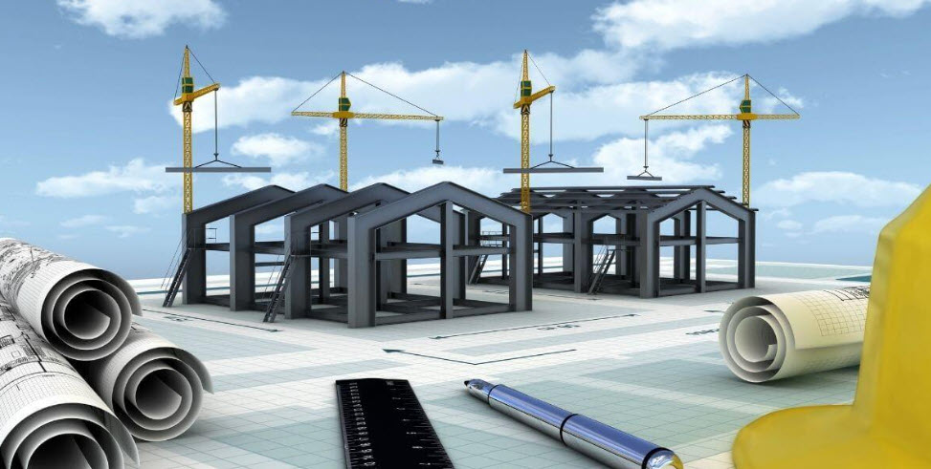

Economic Impact
The construction sector is a major contributor to the EU's economy:
- It generates about 9% of the EU's GDP (EBC, n.d.) (European Commission, n.d.).
- Construction is a significant source of employment in the EU. The sector provides 18 million direct jobs (European Commission, n.d.).
- The EU construction sector is characterized by a large number of small enterprises. There are more than 3 million enterprises in the construction sector (EBC, n.d.).
The construction sector in the EU is divided into three main activities:
- Specialized construction activities account for 59.0% of construction value added and 63.3% of employment (Construction, n.d.).
- Construction of buildings contributes 26.8% to the sector's value added (Construction, n.d.).
- Civil engineering makes up 14.2% of the construction total (Construction, n.d.).
The construction sector has faced challenges but shows signs of potential recovery:
- In 2023, the EU construction sector contracted by 2.3% (FIEC, n.d.).
- For 2024, a small decline in production volumes (-0.5%) is expected7 (Sante, 2024).
- A marginal increase of 0.5% in total EU construction volumes is projected for 2025 (Sante, ING, 2025).
Subsector Performance
Different subsectors within construction show varying trends:
The renovation subsector, including sustainability works, is experiencing structural growth in demand (Sante, ING, 2024).
Investments in infrastructure are expected to continue growing, driven by EU Recovery funds, digital infrastructure, and energy transition projects (Sante, ING, 2024).

Six major players in the construction industry in the world
- Vinci (France): The largest construction company globally, specializing in infrastructure development and urban transformation with operations in 120 countries. Known for projects like the Atlantic Bridge in Panama and a commitment to sustainable mobility and renewable energy. Market cap: US$62.53bn. (Wheeler, 2024)

- Larsen & Toubro (L&T) (India): A leading Indian engineering and construction powerhouse involved in infrastructure, power, defense, and IT sectors. Constructed India's longest sea bridge and contributes to the country's space program. Market cap: US$59.61bn. (Wheeler, 2024)

- D.R. Horton (USA): America's largest homebuilder by volume, with a focus on diverse housing across various price points, affordable housing, and the build-to-rent sector. Strengthened land development capabilities through the acquisition of Forestar Group. Market cap: US$44.52bn. (Wheeler, 2024)

- Lennar (USA): A major player in the U.S. homebuilding industry, delivering innovative housing solutions. Known for its "Everything's Included" approach, smart home technology, and sustainable building practices. Market cap: US$39.11bn. (Wheeler, 2024)

- China State Construction Engineering (CSCEC) (China): A significant global infrastructure company with projects like the Beijing National Stadium and the Burj Khalifa. Involved in developing eco-cities and smart urban complexes across China. Market cap: US$31.24bn. (Wheeler, 2024)

- Ferrovial (Spain): A global leader in infrastructure development and services, spanning transportation, urban mobility, and sustainable infrastructure. Notable achievements include the 407 ETR highway in Canada and London's Heathrow Airport management. Market cap: US$28.54bn. (Wheeler, 2024)

Six major players in the construction industry in the Netherlands
Based on the most recent data available from the search results, here are the market capitalizations for the six Dutch companies:
- Royal BAM Group N.V.: €1.29 billion (MarketScreener, 2025)
- Aalberts N.V.: €3.74 billion (Stock Analysis, 2025)
- Arcadis N.V.: €5.01 billion (Stock Analysis, 2025)
- Heijmans N.V.: €930.86 million (Stock Analysis, 2025)
- Cementir Holding N.V.: €1.98 billion (Stock Analysis, 2025)
- SIF Holding N.V.: €328.77 million (Stock Analysis, 2025)

Chart 1: Company Capitalizations

Industry Analysis
Six key players in the construction industry in the Netherlands:
Company | Primary Activities | Recent Innovations | Main Issue
BAM Group N.V. | - Construction and property development  - Civil engineering  - Public-private partnerships | - Opened a production facility for sustainable wooden Flow homes.  - Developed hydrogen as an alternative to diesel on construction sites (Element One project).  - Focused on energy transition and rail infrastructure markets (MarketScreener, 2025) | Regulatory hurdles, land scarcity, and network congestion impacting project execution and expansion (BAM, 2025)
Arcadis N.V. | - Architecture and engineering design  - Construction consultancy | - Implemented AI and data analytics for asset optimization.  - Expanded technology-enabled solutions for the asset lifecycle.  - Enhanced digital product offerings for efficiency savings (arcadis, 2023) | Adapting to stricter environmental regulations and managing operational costs amid sustainability demands (arcadis, 2023)
Aalberts N.V. | - Manufacturing mission-critical technologies  - Surface and heat treatments | - Invested in electrically powered multifunctional furnaces.  - Developed mechatronic systems for high-end machines.  - Focused on ultra-high purity liquid and gas supply systems for semiconductors (Aalberts, n.d.) | Declining revenue in cyclical segments, high material costs, and undervaluation of stock price (Aalberts, 2025)
Heijmans N.V. | - Property development  - Residential and non-residential building  - Infrastructure development | - Adopted modular construction techniques.  - Reduced CO2 emissions by 30% (2024 vs. 2023) and aims for climate neutrality by 2040.  - Experimenting with rainwater reuse and energy management systems.  - Launched the BioBuddy biodiversity monitoring box.  - Improved safety strategies, reducing incident severity and frequency rates (heijmans, 2025) | Delays in permitting, housing market stagnation, and supply chain disruptions affecting project timelines (heijmans, 2025)
Cementir Holding N.V. | - Cement production  - Ready-mixed concrete manufacturing  - Aggregates processing  - Waste management | - Introduced FUTURECEM™ technology, reducing CO2 emissions by 30%.  - Expanded FUTURECEM™ to France and Benelux.  - Developed Ultra-High-Performance Concrete (UHPC) products.  - Implemented Cementir 4.0 digitalization project.  - Committed to a 30% CO2 reduction by 2030 with €107 million in sustainability projects.  - Collaborated on CALLISTE research for further CO2 reductions (cementirholding, 2023) | Delays in permitting, housing market stagnation, and supply chain disruptions affecting project timelines (think.ing, 2024)
SIF Holding | - Offshore wind turbine monopile manufacturing  - Transition pieces and pin-piles | - Built the world’s largest monopile manufacturing plant in Rotterdam (€328 million investment).  - Increased production capacity to 500 kilotons/year.  - Developed XXXL monopiles (up to 11.5m diameter, 2,500 tons).  - Improved sustainability through electrification of production processes.  - Innovated technologies like Skybox for TP-Less foundations and green steel transition.  - Produced first monopile at expanded Maasvlakte II plant in late 2024 (Sif, n.d.) | Dependence on offshore wind market growth while managing supply chain and production efficiency issues (Sif, n.d.)
Table 1: Six key industry players

Market Capitalization Revenue
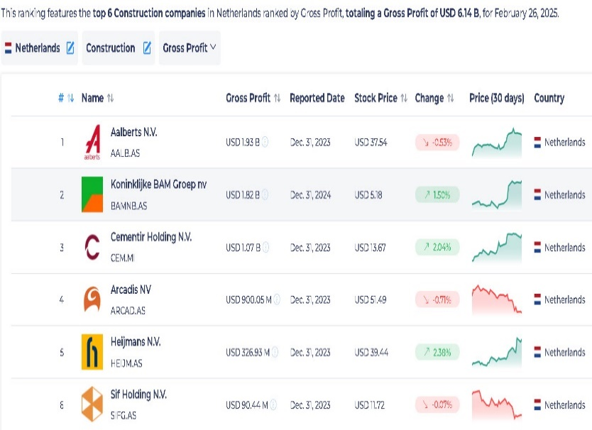  Image1: Market Capitalization (StockViz, 2025) | 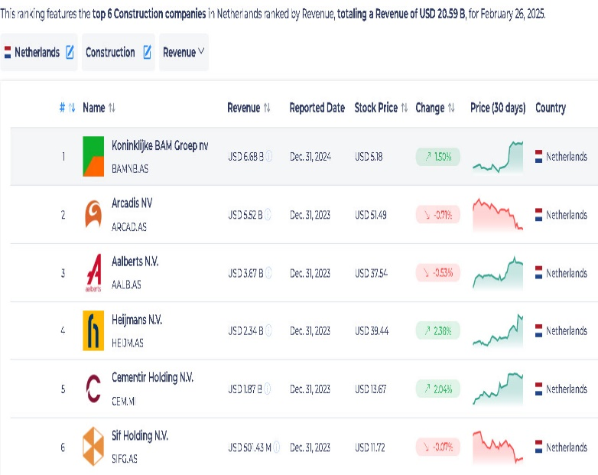  Image2: Revenue (StockViz, 2025)

The Biggest challenges in the mentioned companies
Company | Biggest Challenges
BAM Group N.V. | - Attracting and retaining skilled employees.  - Uncertainty regarding interest rates, Dutch nitrogen regulations, and political unrest.  - Supply chain issues and project delays in construction markets, particularly in the UK (BAM, 2025)
Arcadis N.V. | - Rising costs of implementing digital and AI technologies.  - Managing workforce transitions to adopt new technology.  - Balancing sustainability goals with client demands for cost efficiency (arcadis, 2023)
Aalberts N.V. | - Skilled labor shortages, particularly engineers, impacting innovation.  - High raw material costs and inflation affecting profitability.  - Low productivity growth in European machinery market (Aalberts, 2025)
Heijmans N.V. | - Regulatory challenges with stricter sustainability standards.  - Rising material costs due to inflation.  - Delays in project completions caused by supply chain disruptions.  - High costs of transitioning to emission-free construction (heijmans.nl, n.d.)
Cementir Holding N.V. | - High investment requirements for sustainability projects (e.g., FUTURECEM™ expansion).  - Balancing CO2 reduction targets with operational efficiency.  - Competition in the cement market for low-emission products (cementirholding, 2023)
SIF Holding | - Managing high capital investments (€328 million) for new facilities.  - Transitioning to green steel and low-noise pile-driving technologies.  - Adapting to stricter sustainability regulations while maintaining profitability (Sif, n.d.)

Three selected companies
Based on the search results, I'll focus on three prominent construction companies in the Netherlands based on the GDP.

1. Aalberts N.V.
- Why this company? Aalberts N.V. is chosen because it has the highest gross profit among construction companies in the Netherlands, at USD 1.93 billion. This indicates a strong financial performance and significant market presence. Also, with its focus on surface and heat treatments, Aalberts is essential in the construction sector. (Aalberts, 2025)

- What is the main issue in this company? According to my research, the primary challenges for Aalberts N.V. are "Declining revenue in cyclical segments, high material costs, and undervaluation of stock price". (Aalberts, 2025)

- How can we address the issue? Mitigation strategies include:
- Diversification into Growth Markets: Target expansion into sectors with strong growth potential, such as sustainable infrastructure and renewable energy, to offset revenue declines in cyclical segments.
- Cost Optimization: Implement rigorous cost management strategies to mitigate the impact of high material costs and improve profitability.
- Investor Relations and Value Communication: Proactively communicate the company's strategic initiatives and long-term value proposition to investors to address the undervaluation of the stock price. (Aalberts, 2025)

2. Koninklijke BAM Groep nv (Royal BAM Group N.V.)
- Why this company? Royal BAM Group N.V. is included because it is among the top companies with a strong gross profit in the construction and property development business. (BAM, 2025)

- What is the main issue in this company? The main challenges for Royal BAM Group N.V. revolve around "Regulatory hurdles, land scarcity, and network congestion impacting project execution and expansion”. (BAM, 2025)

- How can we address the issue? Strategies to overcome these challenges involve:
- Strengthened Stakeholder Engagement: Engage with regulatory bodies to streamline approval processes and reduce delays in project execution.
- Optimized Supply Chain Management: Enhance supply chain management practices to minimize disruptions and ensure timely project completion. (BAM, 2025)

3. Heijmans N.V.
- Why this company? The high gross profit makes Heijmans N.V a top company in the construction sector. (heijmans, 2025)

- What is the main issue in this company? The main challenges for Heijmans include "rising material costs, regulatory changes (particularly regarding nitrogen emissions), and maintaining affordability while transitioning to more sustainable practices". (heijmans, 2025)

- How can we address the issue? To address these issues, Heijmans can:
- Invest in modular and industrial construction techniques to improve efficiency and affordability.
- Collaborate with policymakers to streamline permitting processes, especially regarding environmental regulations.
- Focus on sustainable housing solutions and energy transition projects to align with regulations and market demands. (heijmans, 2025)

References
Aalberts. (n.d.). Retrieved from https://aalberts.com/sustainability
Aalberts. (2025, February 27). Retrieved from Aalberts delivers resilient performance in challenging markets: https://aalberts-website.s3.eu-west-1.amazonaws.com/media/App/Models/Download/000/000/493/attachment/original/FY2024.pdf
arcadis. (2023). Retrieved from https://www.arcadis.com/en/news/global/2023/11/arcadis-presents-its-2024-2026-strategy-accelerating-a-planet-positive-future
ARCADIS. (2025, February). Retrieved from Arcadis Fourth Quarter and Full Year Results 2024: https://www.arcadis.com/en/news/global/2025/2/arcadis-fourth-quarter-and-full-year-results-2024
bam. (n.d.). Retrieved from Building a sustainable tomorrow: https://www.bam.com/en/about-bam/strategy
BAM. (2025, February 13). Retrieved from https://www.bam.com/sites/bamc/files/2025-02/bam-2025-02-13-q4-2024-en-press-release.pdf
cementirholding. (n.d.). Retrieved from Product innovation: https://www.cementirholding.com/en/our-business/innovation/product-innovation
cementirholding. (2023). Retrieved from cementirholding annual report: https://aalborgportlandholding.com/sites/default/files/documenti/2024-09/Cementir%20Holding%20Annual%20Report%202023.pdf
CFA institite. (n.d.). Retrieved from CFA institite: https://cfasociety.nl/uploads/2024/20240301%20research%20challenge/Aalberts%20CFA%20Research%20Challenge%20-%20FM1%20Uttrecht.pdf
Construction. (n.d.). Retrieved from ec.europa.eu: https://ec.europa.eu/eurostat/cache/htmlpub/key-figures-on-european-business-2022/construction.html
dcfmodeling. (n.d.). Retrieved from Understanding Heijmans N.V. Revenue Streems: https://dcfmodeling.com/blogs/health/heijmas-financial-health
EBC. (n.d.). Retrieved from Representing construction SMEs & craftsmen in Europe: https://www.ebc-construction.eu/about-us/facts-figures/
EGERIA. (2023). Retrieved from https://egeriagroup.com/news/sif-takes-final-investment-decision-to-construct-the-worlds-largest-monopile-foundation-manufacturing-plant/
European Commission. (n.d.). Retrieved from Construction sector: https://single-market-economy.ec.europa.eu/sectors/construction_en
FIEC. (n.d.). Retrieved from Overall construction activity: https://fiec-statistical-report.eu/european-union
Gerrand, N. (2024, June). constructionbriefing. Retrieved from The European construction industry in 4 charts: https://www.constructionbriefing.com/news/the-european-construction-industry-in-4-charts/8037704.article
heijmans. (2025, February). Retrieved from https://www.heijmans.nl/en/news/heijmans-to-use-innovations-in-construction-of-new-data-centre/
heijmans.nl. (n.d.). Retrieved from On the way to emission-free construction: https://www.heijmans.nl/en/stories/on-the-way-to-emission-free-construction/
investing.com. (2025, February 27). Retrieved from Earnings call transcript: Aalberts Q4 2025 sees revenue decline, stock dips: https://www.investing.com/news/transcripts/earnings-call-transcript-aalberts-q4-2025-sees-revenue-decline-stock-dips-93CH-3895184
MarketScreener. (2025). Retrieved from https://www.marketscreener.com/quote/stock/ROYAL-BAM-GROUP-N-V-6378/news/Royal-BAM-N-Press-release-bam-2025-02-13-q4-2024-en-press-release-49049993/
MarketScreener. (2025). Retrieved from https://www.marketscreener.com/quote/stock/KONINKLIJKE-HEIJMANS-N-V-6409/news/Royal-Heijmans-strong-year-and-positive-outlook-for-2025-49121833/
MarketScreener. (2025, February 25). Retrieved from MarketScreener: https://nl.marketscreener.com/koers/aandeel/ROYAL-BAM-GROUP-N-V-6378/
Sante, M. v. (2024, March 18). ING. Retrieved from EU construction sector faces year of decline but green shoots appear: https://think.ing.com/articles/eu-construction-sector-faces-year-of-decline-but-green-shoots-appear/
Sante, M. v. (2024, March 18). ING. Retrieved from EU construction sector faces year of decline but green shoots appear: https://think.ing.com/articles/eu-construction-sector-faces-year-of-decline-but-green-shoots-appear/
Sante, M. v. (2025, January 21). ING. Retrieved from Growth returns to Europe’s construction sector: https://think.ing.com/articles/returning-but-low-growth-expected-in-the-european-construction-sector/
Sif. (n.d.). Retrieved from Product innovation at Sif: https://sif-group.com/en/product-innovation/
Stock Analysis. (2025, January 24). Retrieved from Aalberts Market Cap: https://stockanalysis.com/quote/ams/AALB/market-cap/
Stock Analysis. (2025, January 24). Retrieved from Aalberts Market Cap: https://stockanalysis.com/quote/ams/AALB/market-cap/
Stock Analysis. (2025, February 19). Retrieved from Koninklijke Heijmans Market Cap: https://stockanalysis.com/quote/ams/HEIJM/market-cap/
Stock Analysis. (2025, March 5). Retrieved from Sif Holding Market Cap.
Stock Analysis. (2025, March 5). Retrieved from Cementir Holding Market Cap: https://stockanalysis.com/quote/bit/CEM/market-cap/
StockViz. (2025, February). Retrieved from Top Construction companies in Netherlands by Gross Profit: https://stockviz.com/en/ranking-of-netherlands-stocks-in-construction-by-gross-profit
think.ing. (2024, July 5). Retrieved from Clear signs of recovery for Dutch new housing market in 2025: https://think.ing.com/articles/clear-signs-of-recovery-for-dutch-new-housing-market-in-2025/
vonwood. (2024, December 9). Retrieved from Dutch Construction Sector Faces Challenges but Braces for Gradual Recovery: https://app.vonwood.com/en/articles/dutch-construction-industry-growth-2025
Wheeler, K. (2024, July 3). Constructiondigital. Retrieved from Top 10: Largest Construction Companies: https://constructiondigital.com/top10/top-10-largest-construction-companies
worldcement. (2022, March). Retrieved from Cementir Group launches FUTURECEM in France and Benelux: https://www.worldcement.com/europe-cis/02032022/cementir-group-launches-futurecem-in-france-and-benelux/

